Tetragonal Trapezohedron

Definition
# Source: AI Source: Provided by: [Data Path: Persons Table -> ID Column: 1, Name_En Column: Motasem Essam] -> From: [ChatGPT] on [7/25/2026]
A Tetragonal Trapezohedron is a convex polyhedron with eight congruent kite-shaped faces, arranged symmetrically around a central fourfold rotational axis.
It is also known as a Deltoidal Icositetrahedron? No. The tetragonal trapezohedron is the deltoidal tetrahedron? These names refer to different solids. The standard tetragonal trapezohedron is an eight-faced solid and is commonly used as the shape of a four-sided (D4) gaming die only in certain nonstandard forms.

Simple Definition
# Source: AI Source: Provided by: [Data Path: Persons Table -> ID Column: 1, Name_En Column: Motasem Essam] -> From: [ChatGPT] on [7/25/2026]
A tetragonal trapezohedron is a three-dimensional solid made of eight identical kite-shaped faces, with four vertices arranged around its middle and two opposite vertices at the ends of its central axis.
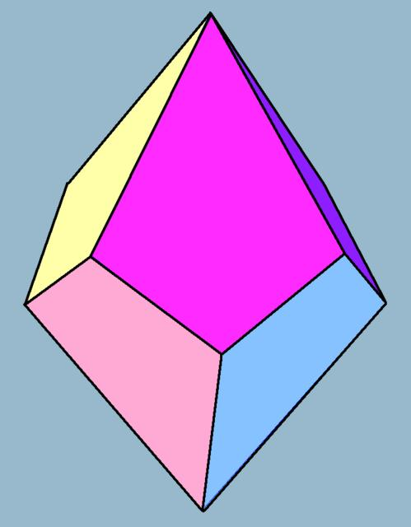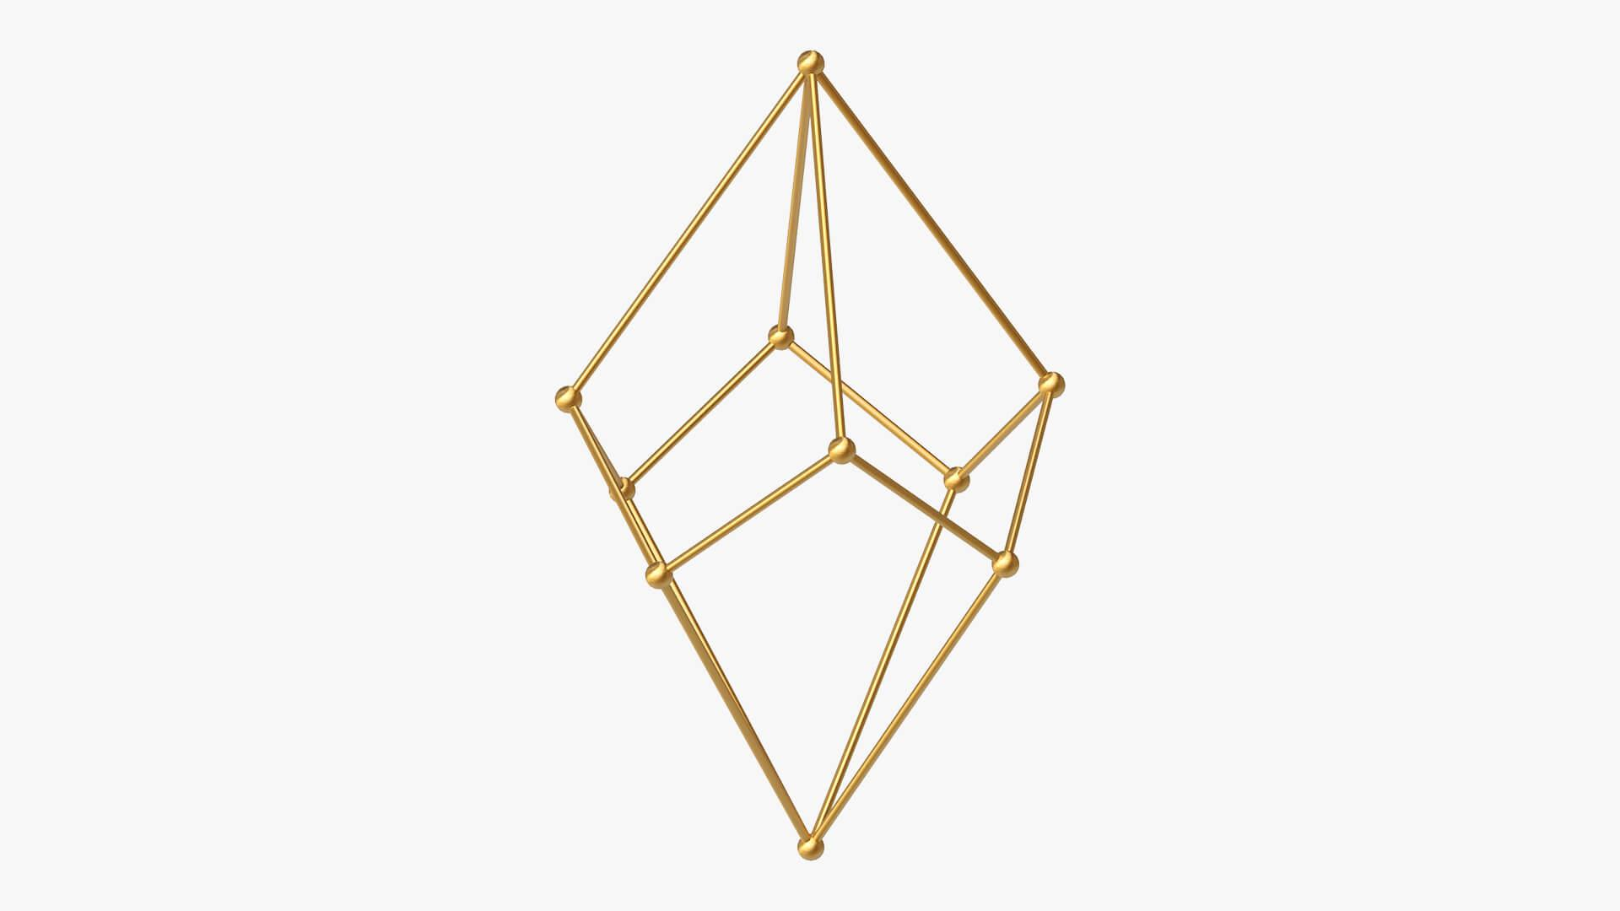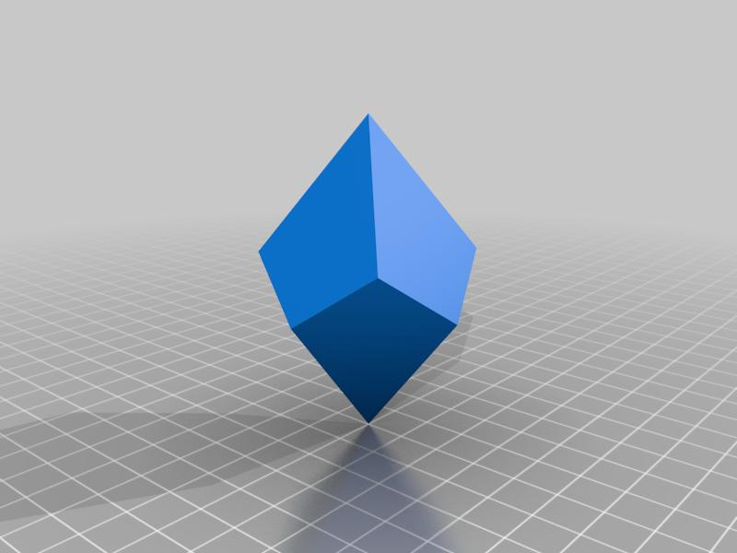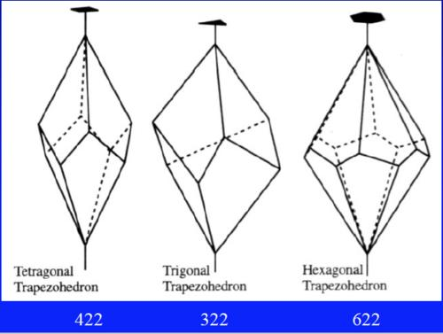

Geometric Structure
# Source: AI Source: Provided by: [Data Path: Persons Table -> ID Column: 1, Name_En Column: Motasem Essam] -> From: [ChatGPT] on [7/25/2026]
The tetragonal trapezohedron has the following elements:
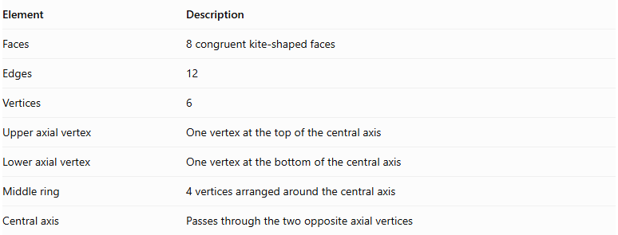
Element | Description
Faces | 8 congruent kite-shaped faces
Edges | 12
Vertices | 6
Upper axial vertex | One vertex at the top of the central axis
Lower axial vertex | One vertex at the bottom of the central axis
Middle ring | 4 vertices arranged around the central axis
Central axis | Passes through the two opposite axial vertices

Face Structure
# Source: AI Source: Provided by: [Data Path: Persons Table -> ID Column: 1, Name_En Column: Motasem Essam] -> From: [ChatGPT] on [7/25/2026]
Each face is a kite-shaped quadrilateral with:
- Two pairs of adjacent equal sides.
- One pair of opposite angles that are equal.
- Two diagonals that intersect perpendicularly.
- One diagonal that bisects the other.
The eight faces are congruent and form the complete closed surface.

Edge Structure
# Source: AI Source: Provided by: [Data Path: Persons Table -> ID Column: 1, Name_En Column: Motasem Essam] -> From: [ChatGPT] on [7/25/2026]
The edges can be classified into two groups:
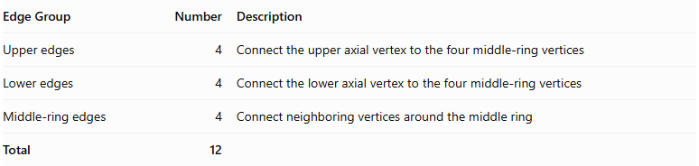
Edge Group | Number | Description
Upper edges | 4 | Connect the upper axial vertex to the four middle-ring vertices
Lower edges | 4 | Connect the lower axial vertex to the four middle-ring vertices
Middle-ring edges | 4 | Connect neighboring vertices around the middle ring
Total | 12

Vertex Structure
# Source: AI Source: Provided by: [Data Path: Persons Table -> ID Column: 1, Name_En Column: Motasem Essam] -> From: [ChatGPT] on [7/25/2026]
The solid has six vertices:
- 1 upper axial vertex.
- 1 lower axial vertex.
- 4 middle-ring vertices.
$$V=2+4=6$$
At each axial vertex, four faces meet. At each middle-ring vertex, four faces also meet.

Mathematical Properties

A. Number of Faces
# Source: AI Source: Provided by: [Data Path: Persons Table -> ID Column: 1, Name_En Column: Motasem Essam] -> From: [ChatGPT] on [7/25/2026]
$$F=2n=2(4)=8$$

B. Number of Edges
# Source: AI Source: Provided by: [Data Path: Persons Table -> ID Column: 1, Name_En Column: Motasem Essam] -> From: [ChatGPT] on [7/25/2026]
$$E=3n=3(4)=12$$

C. Number of Vertices
# Source: AI Source: Provided by: [Data Path: Persons Table -> ID Column: 1, Name_En Column: Motasem Essam] -> From: [ChatGPT] on [7/25/2026]
$$V=n+2=4+2=6$$

D. Euler's Formula
# Source: AI Source: Provided by: [Data Path: Persons Table -> ID Column: 1, Name_En Column: Motasem Essam] -> From: [ChatGPT] on [7/25/2026]
$$V-E+F=2$$
$$6-12+8=2$$
<badge color="success">Verified</badge> Euler's formula is satisfied.

Symmetry
# Source: AI Source: Provided by: [Data Path: Persons Table -> ID Column: 1, Name_En Column: Motasem Essam] -> From: [ChatGPT] on [7/25/2026]
A standard symmetric tetragonal trapezohedron has:
- A fourfold rotational symmetry axis.
- Fourfold rotational symmetry around its central axis.
- Reflection symmetry planes containing the central axis.
- Central inversion symmetry when its upper and lower portions are arranged symmetrically.

Constructing Tetragonal Trapezohedron in Solid Geometry

Geometric Instruments Used
# Source: AI Source: Provided by: [Data Path: Persons Table -> ID Column: 1, Name_En Column: Motasem Essam] -> From: [ChatGPT] on [7/25/2026]
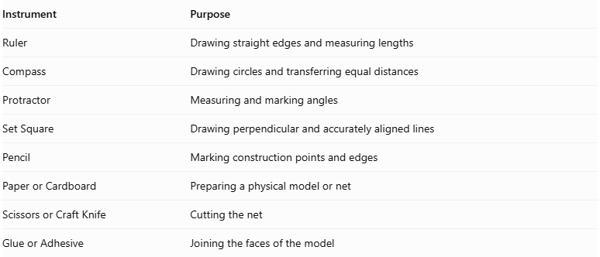
Instrument | Purpose
Ruler | Drawing straight edges and measuring lengths
Compass | Drawing circles and transferring equal distances
Protractor | Measuring and marking angles
Set Square | Drawing perpendicular and accurately aligned lines
Pencil | Marking construction points and edges
Paper or Cardboard | Preparing a physical model or net
Scissors or Craft Knife | Cutting the net
Glue or Adhesive | Joining the faces of the model

Instrument-Based Construction Procedures
# Source: AI Source: Provided by: [Data Path: Persons Table -> ID Column: 1, Name_En Column: Motasem Essam] -> From: [ChatGPT] on [7/25/2026]
The tetragonal trapezohedron can be constructed using geometric instruments through a symmetry-based drawing process.

Preparing the Central Axis
# Source: AI Source: Provided by: [Data Path: Persons Table -> ID Column: 1, Name_En Column: Motasem Essam] -> From: [ChatGPT] on [7/25/2026]
- Draw a vertical reference line representing the central axis.
- Mark the intended upper and lower axial vertices.
- Establish the central region where the two staggered vertex rings will be positioned.

Constructing the Two Vertex Rings
# Source: AI Source: Provided by: [Data Path: Persons Table -> ID Column: 1, Name_En Column: Motasem Essam] -> From: [ChatGPT] on [7/25/2026]
- Use a compass to draw the reference circles for the upper and lower rings.
- Divide each circle into four equally spaced positions.
- Use a protractor to mark the angular positions.
- Offset the second ring relative to the first to create the staggered arrangement.
- Mark the four vertices on each ring.

Marking the Axial Vertices
# Source: AI Source: Provided by: [Data Path: Persons Table -> ID Column: 1, Name_En Column: Motasem Essam] -> From: [ChatGPT] on [7/25/2026]
- Mark the upper axial vertex above the upper ring.
- Mark the lower axial vertex below the lower ring.
- Align both vertices with the central axis.

Constructing the Kite-Shaped Faces
# Source: AI Source: Provided by: [Data Path: Persons Table -> ID Column: 1, Name_En Column: Motasem Essam] -> From: [ChatGPT] on [7/25/2026]
- Connect the upper axial vertex to the appropriate vertices of the upper and lower rings.
- Connect the lower axial vertex to the corresponding ring vertices.
- Join neighboring vertices from the two rings according to the trapezohedron's face arrangement.
- Ensure that the resulting eight quadrilaterals are kite-shaped.
- Check that shared edges have matching lengths.

Completing the Three-Dimensional Drawing
# Source: AI Source: Provided by: [Data Path: Persons Table -> ID Column: 1, Name_En Column: Motasem Essam] -> From: [ChatGPT] on [7/25/2026]
- Draw the visible edges using continuous lines.
- Represent hidden edges using dashed lines when necessary.
- Check that all eight faces are connected correctly.
- Verify that the drawing contains 10 vertices and 16 edges.

Constructing a Physical Model
# Source: AI Source: Provided by: [Data Path: Persons Table -> ID Column: 1, Name_En Column: Motasem Essam] -> From: [ChatGPT] on [7/25/2026]
- Draw a valid net containing eight correctly connected kite-shaped faces.
- Add tabs along selected outer edges.
- Cut out the net carefully.
- Fold along the shared face boundaries.
- Join the corresponding edges using adhesive.
- Check that the assembled model forms a closed tetragonal trapezohedron.
Construction note: This is an instrument-based geometric construction using rulers, compasses, protractors, and geometric relationships. It does not use coordinate-based construction.

Relationship to Other Solids
# Source: AI Source: Provided by: [Data Path: Persons Table -> ID Column: 1, Name_En Column: Motasem Essam] -> From: [ChatGPT] on [7/25/2026]
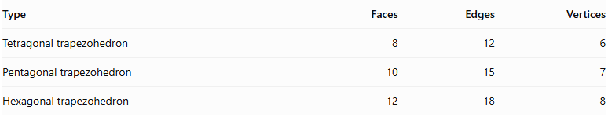
Type | Faces | Edges | Vertices
Tetragonal trapezohedron | 8 | 12 | 6
Pentagonal trapezohedron | 10 | 15 | 7
Hexagonal trapezohedron | 12 | 18 | 8

Key Points
# Source: AI Source: Provided by: [Data Path: Persons Table -> ID Column: 1, Name_En Column: Motasem Essam] -> From: [ChatGPT] on [7/25/2026]
- A tetragonal trapezohedron has eight congruent kite-shaped faces.
- It has twelve edges and six vertices.
- Four vertices form the middle ring.
- Two vertices lie at opposite ends of the central axis.
- Its standard symmetric form has a fourfold rotational axis.
- It satisfies Euler's polyhedron formula.

Conclusion
# Source: AI Source: Provided by: [Data Path: Persons Table -> ID Column: 1, Name_En Column: Motasem Essam] -> From: [ChatGPT] on [7/25/2026]
The Tetragonal Trapezohedron is the four-sided-ring form of a trapezohedron. It consists of eight congruent kite-shaped faces, twelve edges, and six vertices, with a central fourfold rotational axis.
Classification note: The tetragonal trapezohedron is topologically an octahedron, but its faces are generally kite-shaped rather than necessarily equilateral triangles.

